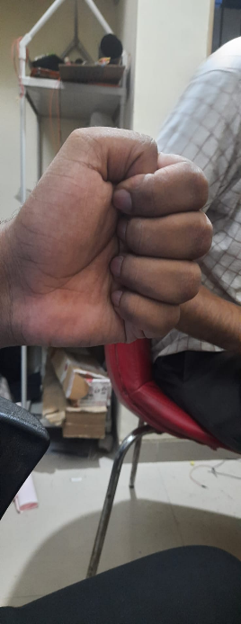 Left= Hello Right=it’s holiday today

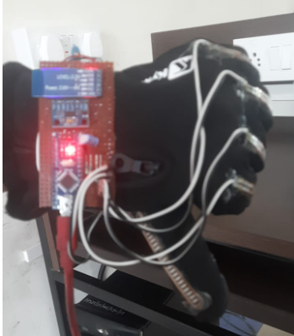 Left=Not Okay Right= Please leave me alone

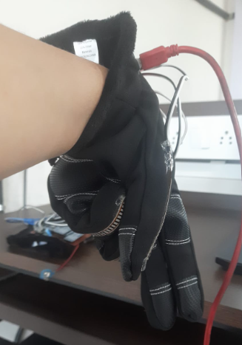 Left=Talk later Right= I am angry

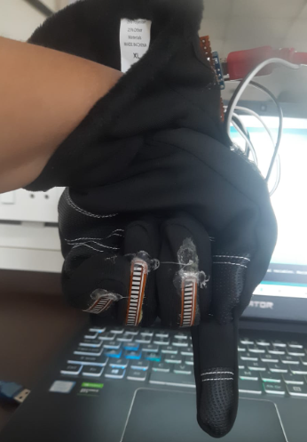 Left= Down Right=This is where we started

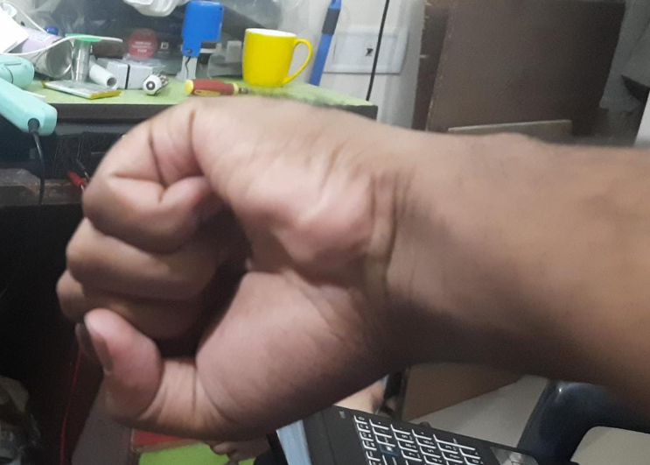 left=Pause Please Right=let’s start

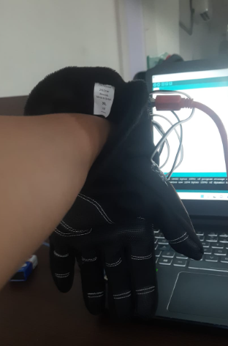 Left=No more work today Right=sorry to hear that

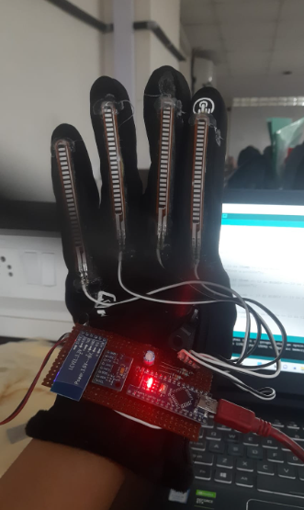 Left= I want to sleep Right=see you at 4

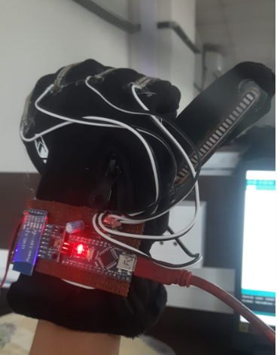 left= water please Right=let’s go for a walk

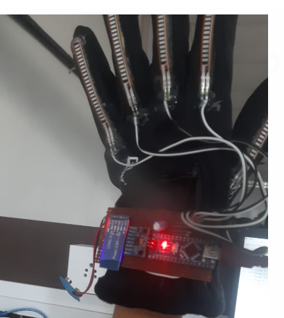 left=Hi how are you Right=see you soon

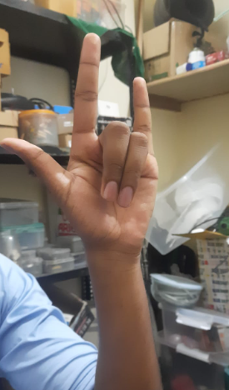 Left= Music Right=let’s chill for some time

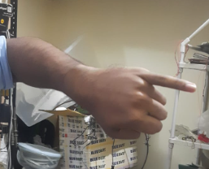 Left=I am out of this Right= This is not mine

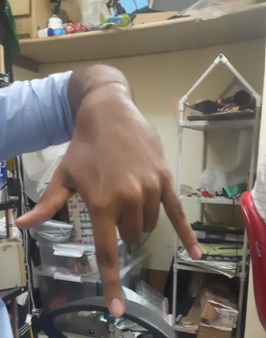 Left= No noise Right=party is done

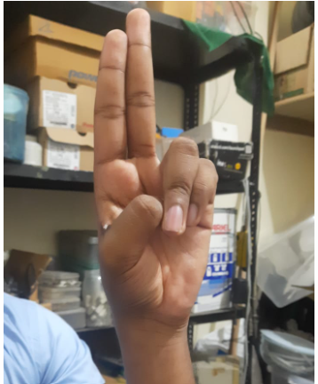 Left=nice to miss you Right=will talk this on call

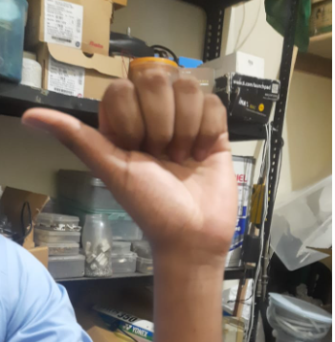 Left= want some water Right=go and have it by yourself

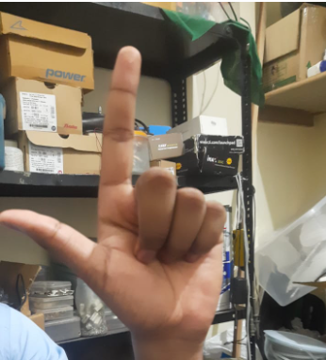 Left=click a picture Right= let it be

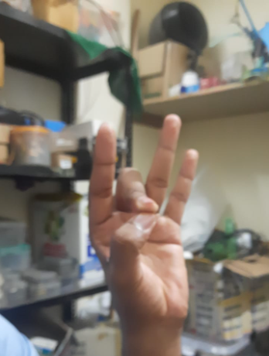 Left= Bird Right=dog

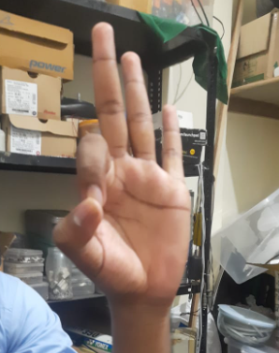 Left= Amazing Right= Nice food

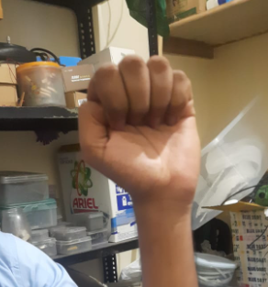 Left= Peace Right= Unity

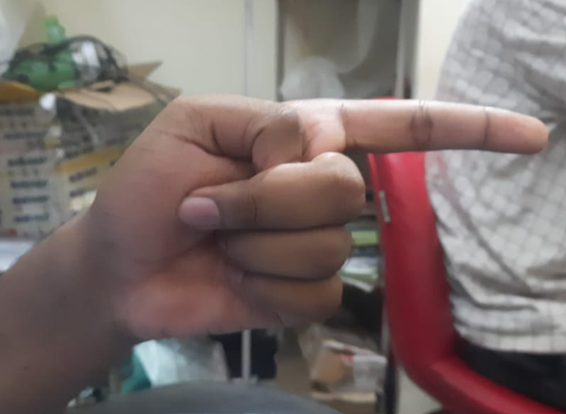 Left= check the door Right=please wait outside

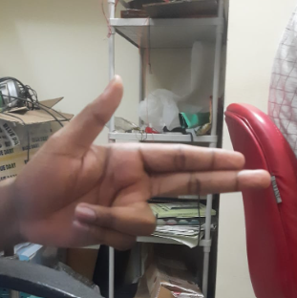 Left= I will kill you Right=danger

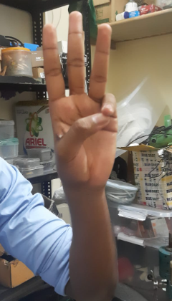 Left=lets eat Right=its done now

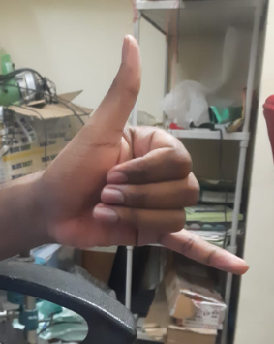 Left=Take my number Right= it was okay

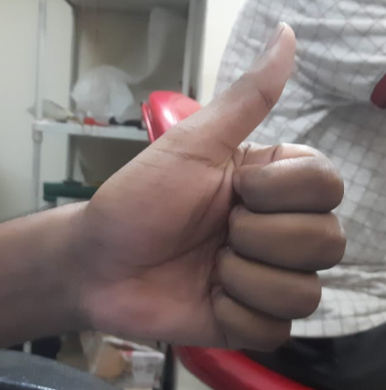 left= understood Right=yes final

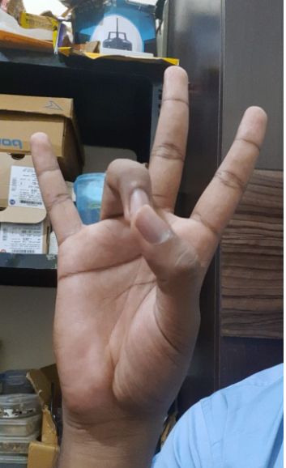 Left= I am leaving Right=I am coming

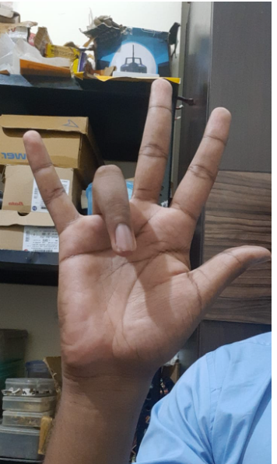 left=I was thinking about you Right=can we meet?

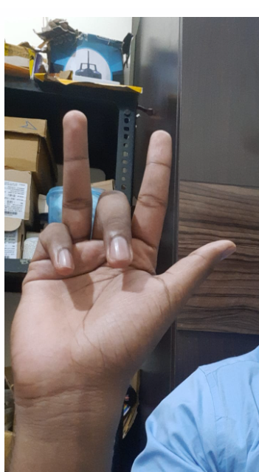 Left= I want to buy vegetables Right= Fruits

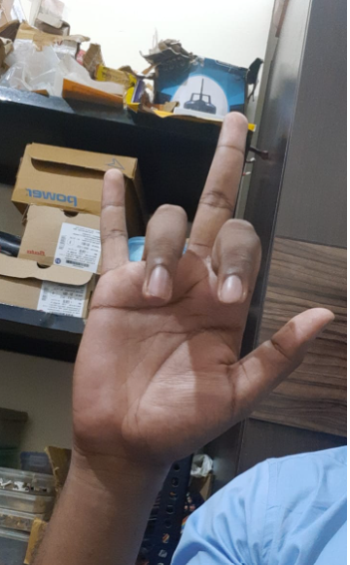 Left=good quality Right=Bad quality

Double

 I surrender

  Fight with me

  Sit Down

  Stand Up

  All the best